

Where to Play - AI Workbook

Introduction: Using AI to Support Your Market Opportunity Evaluation
The advent of Generative AI has created tools that can do some truly helpful — even amazing — things. These tools can analyze information, spot patterns, generate insights, and help you think through complex strategic decisions in ways that would have taken hours or days just a few years ago. But here's the thing: the very capabilities that make these tools so powerful can also make it easy to forget their limitations.
If you're new to working with Gen AI, you're more likely to stumble into common traps — like hallucinations (when AI confidently generates information that simply isn't true), bias (when AI reflects problematic patterns from its training data), or overly "pleasing" responses (when AI tells you what it thinks you want to hear rather than giving you the critical analysis you need). We've observed that many people are already turning to Generative AI for help with the Market Opportunity Navigator — often using quite basic prompts like asking ChatGPT to score their Market Opportunity Sets in a single step. While we understand the impulse to leverage these powerful new tools, this kind of "naive prompting" can lead you astray.
That's why we created this AI Workbook: to give you a more structured, thoughtful approach to using AI alongside the "Where to Play" framework. These tools hold real promise as a support system for strategic decision-making — they can help you research markets, extract signals from complex information, recommend initial scoring, and serve as a sparring partner as you think through your options. This workbook provides you with carefully crafted prompts designed to help you leverage these capabilities effectively.
But here's what's equally important: even with better prompts, AI remains a tool that requires your critical judgment. Think of it as a well-informed assistant, not an oracle. Stay alert, question its outputs, and trust your own expertise and knowledge of your innovation. Our goal is to help you use AI as a valuable thinking partner in your evaluation process — one that supports and enriches your strategic thinking, but never replaces it.

A Note on AI Tools and Compatibility
The prompt templates in this workbook were developed and tested primarily with ChatGPT Plus (specifically the GPT-5 model). That said, they should generally work well with other leading AI chatbots, including Google Gemini, Anthropic Claude, and Microsoft 365 Copilot. Just keep in mind that results may vary across different platforms — each Gen AI product has its own strengths, quirks, and ways of interpreting prompt instructions.
Also worth noting: AI model generations are evolving and changing fast. What works beautifully today might need adjusting tomorrow as these tools continue to develop. Stay flexible, experiment with different approaches, and remember that you're the expert on your startup — the AI is just here to support your thinking, not replace it.

What’s in this workbook
This AI workbook focuses on Worksheet 2 of the Market Opportunity Navigator. It includes three prompt templates that can guide you through a meaningful evaluation process:

#1 Deep Research: Gathering Market Intelligence for a market opportunity
For every market opportunity in your set, this prompt will help you gather and synthesize information for a comprehensive market intelligence. It will provide resources and insights relevant to each of the 3 factors that shape the potential and each of the 3 factors that shape the challenge of a market opportunity.
*Recommended tool: ChatGPT-5 Deep Research
*Required input: Description of the market opportunity + your core competencies

#2 Scoring a Market Opportunity
Once the deep research for a specific market opportunity is done, this follow-up prompt will provide recommendations on the scoring of each factor in Worksheet 2. The overall potential and overall challenge scoring will not be provided by the chat, set them manually based on your critical judgment.
*Recommended tool: ChatGPT-5 Extended Thinking
*Required input: none (a follow-up on the Deep Research report created with Prompt#1)

#3 Relative Scoring: Calibrating Across Your Market Opportunity Set
After assessing and scoring each market opportunity in your set, this prompt will help you see the bigger picture and calibrate your evaluation in a relative manner.
*Recommended tool: ChatGPT-5 Extended Thinking
*Required input: Your scoring for each market opportunity in your set + the research report created in Prompt#1 (saved as PDF)

#1 Deep Research: Gathering Market Intelligence for a market opportunity
This prompt template is designed for Deep Research agents — AI tools that autonomously search the web across multiple iterations, gathering and synthesizing information from dozens of sources to provide comprehensive market intelligence. While you can also run this prompt in reasoning models like GPT-5 Thinking (with web search enabled), Deep Research requests typically deliver much richer insights because they're built to explore more broadly and dig more deeply over time.
How to use this template:
Run one Deep Research session for each Market Opportunity you're evaluating (always start a new blank chat session per Market Opportunity*). Before sending the prompt, replace the two mandatory placeholders with your own information:
- A brief description of your specific Market Opportunity
- A summary of your Core Capabilities
The template includes some more optional placeholders** that you can customize based on what's most relevant for your situation — simply remove any sections you don't need or want to explore.

*) This is important because we have to work with the limited context windows of chatbots and because we cannot overload the context with different tasks (chatbots cope better with “one task, one chat”).
**) You can recognize the placeholders by the areas marked [RED IN SQUARE BRACKETS]. You'll find an example below the template showing how to complete these placeholders effectively.

💡Pro tip: Editing longer prompts (e.g. replacing the placeholders) is not very convenient in the browser window (Have you ever accidentally sent an unfinished prompt because you pressed “Enter” to insert a new line? Then you know what we mean…). Use a text editor of your choice, then paste the final prompt once you have finished. An added bonus is that you can more easily revisit this prompt later in the process if necessary.

💡Pro tip: If you already have market research, industry studies, or analyst reports related to this opportunity, upload them to your Deep Research session before running the prompt. This gives the AI additional context to work with and can significantly enhance the quality of insights.

Why this prompt focuses only on research (not scoring):
You'll notice this template is deliberately designed to gather market intelligence and signals — nothing more. We've separated research from scoring for two important reasons: First, it makes it easier to revisit and reference your research reports later and use them as context in future chat sessions. Second, it allows us to use more sophisticated, targeted prompting techniques specifically for the scoring phase, which we'll tackle in the next template.

Prompt Template #1 “Deep Research: Gathering Market Intelligence” | Comments
Provide detailed, structured, citation-backed market intelligence for a single Market Opportunity of our venture to inform Worksheet #2 of the Market Opportunity Navigator (MON) - the framework we are using to explore "Where to play". Focus on delivering high-quality evidence, surfaced signals (equally both positive and negative, don’t just look for confirmation), and sources for each of six MON evaluation factors. Do not provide scores or recommendations.  # Market Opportunity Input  ## Market Opportunity  [REPLACE WITH YOUR MARKET OPPORTUNITY]  ## Core Capabilities  [REPLACE YOUR CORE CAPABILITIES]  ## Other Information  [OPTIONAL - REPLACE WITH YOUR OWN DETAILS OR REMOVE SECTION FROM PROMPT]  ## Time Horizon for Data  Prefer 2023-today; use earlier data only for baselines.  [OPTIONAL - REPLACE WITH YOUR OWN DETAILS OR REMOVE SECTION FROM PROMPT]  ## User-Provided Studies/Reports: Incorporate evidence, data, and citations from the additional documents supplied via chat attachments. Reference these uploaded materials as primary sources where applicable, clearly flag their use, and prioritize integrating their key quantitative and qualitative findings into the appropriate sections of the report. If a user-uploaded study appears low quality or lacks credibility, note this in the Source Quality & Search Log but still extract valuable data if relevant.  # Scope & Instructions  ## Objective  - Conduct rigorous, source-backed analysis of the market opportunity, capturing cited evidence and meaningful signals for all six MON factors:  1. **Potential:**  - *Compelling Reason to Buy*  - Unmet need & urgency: Does this segment actually have a pain? What outcome gap exists **today**? What’s the **cost of inaction** (€, hours, risk, compliance) and any **natural urgency** (deadlines, SLAs, safety, outages)?  - **Current alternatives (incl. “do nothing”):** What is used now, and why? What is **like** about it? What frictions or switching costs would block us?  - **Whole-solution fit:** What integrations, data, services, certifications, or reliability thresholds are **required** to succeed on day one? What’s missing we’d need to add?  - *Market Volume* -- Current market size and growth (2-5 years; units and revenue).  - *Economic Viability* -- Price-value fit, costs/margins, buyers' ability to pay, retention/stickiness.  2. **Challenge:**  - *Implementation Obstacles* -- Barriers to develop, deliver, and access the market (capital, talent, supply chain, go-to-market).  - *Time to Revenues* -- Timeline to development, readiness, and first cash flows.  - *External Risks* -- Competitive landscape, dependencies, regulatory or other adoption barriers.  - Only surface evidence and signals (positive or negative) that enable later assessment of these six factors.  - Avoid any immediate scoring, numeric ratings, or recommendations.  ## Deliverables & Format  Produce a Markdown report with these structured sections:  1. **Executive Summary** (≤10 bullets)  - Order from most critical signals (positive or negative) based on strength of evidence.  - Highlight key signals per factor, best sources, and identify 2-3 primary uncertainties or data gaps.  2. **Factor Deep-Dives** (for each MON factor):  - What to Assess (1-2 sentences)  - Key Signals (positive/negative, each with inline citations)  - Evidence & Excerpts (short paraphrases or ≤25-word direct quotes, with citations)  - Quantifications (tables/bullets, labeled units and data types)  - Triangulation Notes (at least two sources for major claims; record resolution of contradictions)  - Gaps / To-verify (clarify unresolved questions; propose next-step probes such as interviews/dataset pulls)  3. **Source Quality & Search Log**  - Markdown table: Source | Publisher | Date | Geography | Type (Primary/Secondary) | URL | Access Date | Credibility Note | Downloadable (Y/N; link if Y)  4. **Appendix**  - Market sizing worksheet (show formulas/calculations in Markdown table)  - Glossary & synonyms list  - Regulatory & standards tracker (table/lists; 'N/A' if not available)  - Competitive landscape snapshot (bullets/table; 'N/A' if not available)  ### Requirements for Quantitative Data  - Present quantitative information as Markdown tables or bullet lists.  - Always label dates, revenues, unit numbers, and durations with explicit units/data types. For timeline data (Gantt/timeline), clarify durations and timeframes.  ## Research Guardrails  - Prioritize sources from the past 24 months; use earlier data as baseline only if more recent is unavailable.  - Favor government/standards sources, tier-1 industry analysts, academic and governmental data over vendor or low-credibility content.  - Triangulate critical facts using at least two independent sources.  - Match geographic relevance to the defined region; if global data is used, explain its applicability to the target geography.  - Quantify wherever possible: prefer ranges over single numbers and always show key assumptions.  - Never offer scores or recommendations--only signals and cited evidence.  - Flag paywalls and suggest open-access or alternative credible sources if possible.  ## Output Structure (Strict)  1. **Executive Summary**  2. **Factor Deep-Dives**  3. **Source Quality & Search Log**  4. **Appendix**  # Completion Criteria  - Stop and deliver output when all above constraints are satisfied, and any missing required inputs are flagged. Signal all omitted or N/A sections explicitly.  - After finalizing output, briefly state (in 1-2 lines) whether all report sections are complete, required fields flagged, and structure validated. If not, correct before completion.  # Verbosity  - Use high verbosity for clarity in quantitative tables, explanations, and attributions; remain concise for summaries. All content should be clearly attributed, structured, and actionable. | Basic task description  The next section where you have to add your own input.  Label your market opportunity and provide a brief explanation. What are you offering? Who are your customers? What is your unique value proposition?  Clearly explain the unique core abilities and technological advantages of your innovation. Also, explain any existing competencies that could give you an edge in this market.  Use this space to provide any additional information you think would be useful for researching this market opportunity (for example: geographical focus, TRL level, estimated cost/BM etc)  We assume that LLMs are “familiar” with the Market Opportunity Navigator, but we will nevertheless briefly define the factors that are important to us.  We do not leave it entirely up to the Deep Research agent to decide on the output format, but rather provide specifications for a meaningful structure.  This also ensures some structural consistency (avoid “output drift”) between multiple Deep Research runs.  A few more rules we set for the research assignment. Remember the rule of thumb that applies when working with chatbots: anything you don't define yourself will be assumed to be a stereotypical standard.  Such “stop conditions” help agents recognize when their task is complete or “motivate” them to continue iterating if this is not yet the case.

Example of how to fill in the placeholders
# Market Opportunity Input
## Market Opportunity
**Mobile power supply for traffic management systems in construction sites**
We offer portable power packs based on highly efficient fuel cell technology, with relatively high power (20-50W), 24/7 uninterrupted service. The customers are the equipment manufacturers who rent the systems to the cities, and they are responsible for the maintenance and service.
Current solutions (batteries + solar panel) offer low capex but high operational cost (opex). Our solution allows for better service and lower maintenance costs, while matching the standard energy ecosystem.
## Core Capabilities
We develop a new generation of power packs based on Solid Oxide fuel cell tech (SOFO), delivering clean, reliable electricity for off-grid and backup applications.
Here are the unique abilities of our innovation
** Mobile power supply**
-Based on Solid Oxide fuel-cell tech
-Modular and scalable (20-2500W)
-Compact, light weight
-Efficient (4 times more than conventional generators)
-Reliable and long lasting (15K hours)
** Fuel flexibility**
-Commercial & standard fuels: Propane, LPG, Natural gas
-Green energy carriers: hydrogen, biofuels, ammonia, ethanol
** Autonomous operation**
-Any weather condition (-20 ° -50°)
-Any altitude (up to 3K meter)
-Standalone (off-grid) or integrated into a hybrid system
-Remote monitoring software
** User friendly**
-Plug & play installment
-Easy to refill
-Low maintenance
-Low capex
-Eco friendly: clean & quiet
## Other Information
### Geographical focus
We are looking at the global market
### Estimated price
Device is expected to be sold at sound 10,000 Euros
### Product readiness
product is developed and tested. Manufacturing at scale not available yet.
## Time Horizon for Data
Prefer 2023-today; use earlier data only for baselines.

💡Pro tip: You might be wondering what the '#' and '**' symbols in the prompt template are for. This is Markdown, a simple way to add structure and emphasis to plain text so that it is easy to read and can be used almost anywhere without the need for special software. This makes it ideal for AI chatbot prompts, as clear sections, lists and delimiters reduce ambiguity, making instructions and context easy to distinguish and helping the model to follow steps and format its output reliably.
https://platform.openai.com/docs/guides/prompt-engineering#message-formatting-with-markdown-and-xml

💡Pro tip: Save the entire research report once it is available: ChatGPT has a download button for this purpose; in other tools, you may need to copy the text and paste it into a plain text* file.
We will need it later for relative scoring, and you can use it later as context in new chat sessions (see the additional tips at the end of the workbook).
*) LLMs digest simple plain text files best (ideally with Markdown formatting). Yes, the best chatbots also accept PDFs, and in some cases even Word or PowerPoint files—but these are also converted into plain text under the hood and contain a lot of noise that only burdens the context.

#2 Scoring a Market Opportunity
Once your Deep Research session has generated a comprehensive market intelligence report, it's time to move from research to scoring. This prompt template guides the AI through a systematic scoring process aligned with Worksheet #2 of the Market Opportunity Navigator — assessing both the Potential and Challenge dimensions of your opportunity.
How to use this template:
Run this prompt in the same Deep Research session immediately after your market intelligence report is complete. For the best results, enable both GPT-5 Thinking and "Extended Thinking" in ChatGPT (see below). This will enforce the GPT-5 reasoning mode. The AI will analyze the research it just generated and recommend transparent, well-reasoned scores for each of the six evaluation factors (it will not provide the overall Potential and Challenge ratings). Importantly, this prompt instructs the AI to provide evidence-based rationales, acknowledge gaps in the data, and maintain critical balance — trying to avoid overly optimistic scores when the evidence doesn't support them.
⚠️A critical note on these recommendations: The scoring suggestions you receive are only as strong as the market intelligence they're based on. If the research has gaps — missing customer perspectives, incomplete competitive data, or limited market sizing — the scores will reflect those limitations. Think of the AI's output as a well-structured first draft that captures what the available signals suggest. Your job is to review these recommendations carefully, check them against your own knowledge and expertise, and iterate. Challenge scores that don't ring true, fill in gaps the AI identified, and refine the evaluation through team discussion. This is the beginning of your evaluation process, not the end.
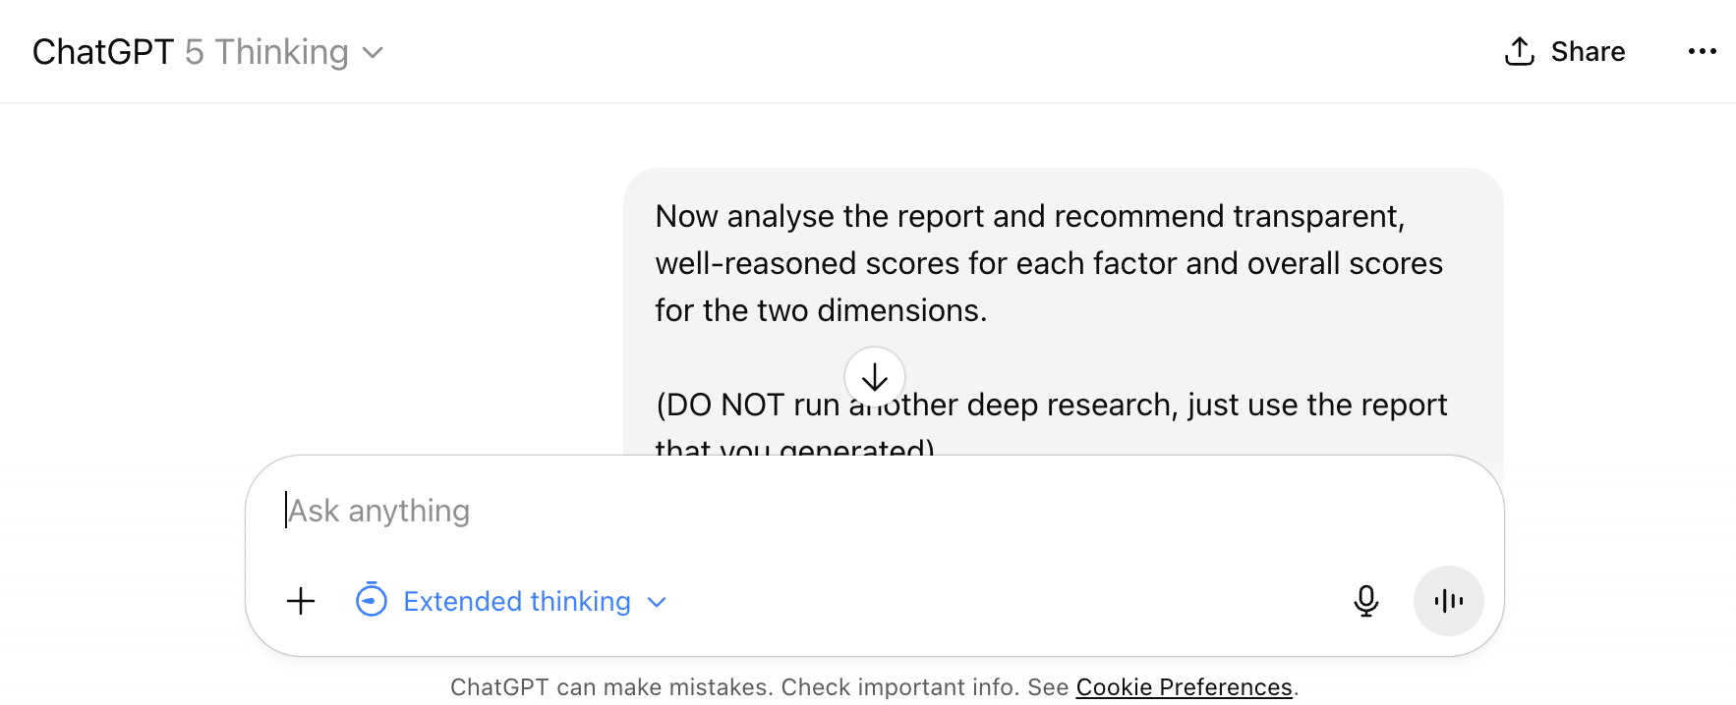

Prompt Template #2 “Scoring Recommendations” | Comments
Now analyse the report and recommend transparent, well-reasoned scores for each factor and overall scores for the two dimensions.  (DO NOT run another deep research, just use the report that you generated)  ## What to deliver  1. **Six factor scores (+ rationale & evidence)**  Score each on a 4-point scale ("low", "mid", "high", "super-high") using the rubrics below. For every score:  * Give a **1–3 sentence rationale** that ties directly to the signals.  * Add **1–2 short quotes** (≤15 words each) from the transcript as evidence, with a brief in-line citation tag like `[Interview 2]` or `[Desk research memo]`.  * If evidence is weak or contradictory, **propose a range (e.g., 3–4)** and state what would tighten it.  * Keep a critical and honest balance: Don't be reluctant to use “low” and “mid” if the signals are not positive enough. Don't try to please me with overly positive ratings: use “high” and “very high” if the evidence and signals are truly present and convincing.  2. **Assumptions & gaps**  * List any **missing data** that materially affects a score and propose **concrete validation steps** (e.g., economic-buyer calls; pilot; bottom-up sizing checks).  3. **One-paragraph takeaway**  * In plain language: “Here’s what’s promising, here’s risky, here’s what to validate next.”  ---  ## Scoring rubrics  ### Potential (value “height”)  1. **Compelling Reason to Buy (CRTB)** – Is there a real unmet need, can we solve it better than alternatives, and will someone pay? **super-high** = must-have + quantified edge + urgency + buyer & budget + hard WTP proof; **high** = strong need & edge but some education or partial proof; **mid** = moderate pain, unclear buyer/budget, or material adoption friction; **low** = nice-to-have / “do nothing” good enough, weak differentiation, or no credible WTP evidence.  2. **Market Volume** – Size now and near-term growth. Prefer **bottom-up** (segments × units × price) and **triangulate with top-down**. **super-high** = very large addressable base with solid growth tailwinds; **high** = sizeable segment with stable/positive growth; **mid** = niche or fragmented demand, growth uncertain; **low** = small/shrinking segment or hard limits on adoption.  3. **Economic Viability** – Attractive margins, funded buyers, stickiness (switching costs, subscriptions, ecosystem lock-in). **Talk to the economic buyer** to validate payback/ROI. **super-high** = robust gross margins + well-funded buyers + strong lock-in/recurring model; **high** = good margins and budgets, reasonable retention; **mid** = one element weak (e.g., margin pressure or shaky budgets) but improvable; **low** = thin margins/price pressure + underfunded buyers + low stickiness.  ### Challenge (effort/risk “slope”)  4. **Implementation Obstacles** – Difficulty to **build, access, and finance** the offer. Scientists: don’t underweight go-to-market vs. tech. **low** = feasible build using existing know-how, ready channels, modest funding; **mid** = some tech or UX work + initial direct sales effort + manageable seed; **high** = significant R&D or regulatory compliance + new channels to create + sizable capital; **super-high** = breakthrough science/clinical/regulatory gauntlet + ecosystem build-out + heavy capital needs.  5. **Time to Revenues** – Development + **market readiness** + **sales cycle** (B2B cycles can be months–years). **low** = short build, market already ready, quick purchase cycles; **mid** = moderate build or some customer education, typical B2B cycle; **high** = long build and/or multi-step pilots, lengthy procurement; **super-high** = very long development/regulatory phases and multi-year adoption cycles. **Calibrate to your category.**  6. **External Risks** – **Competition** (direct/indirect), **dependencies** (platforms, partners), **adoption barriers** (regulation, switching, compliance, security). **low** = clear (even “unfair”) advantage, standalone solution, low adoption barriers; **mid** = some rivals/dependencies but manageable adoption; **high** = intense incumbents or critical partner/regulatory dependence or tough behavior change; **super-high** = powerful incumbents + strong dependencies + heavy regulation + high adoption resistance.  ---  ## MON-aligned guardrails & upgrades (apply while scoring)  * **Use both top-down and bottom-up** to size markets; show workings/assumptions and segment choices; avoid mixing “continents vs. countries.”  * **Center the economic buyer** when judging ROI, pricing power, and stickiness.  * **Calibrate Time to Revenues** with explicit **sales-cycle** evidence (pilot → procurement → rollout).  * **Red-team yourself**: add a “What could make this score one notch worse?” and a “What could make this score one notch better?” line per factor; note contradictory signals.  * **Traceability**: every score must cite at least one concrete quote/snippet from the research. | Basic task description  Because of the nature of the Deep Research agent, it sometimes starts another research run during follow-ups. This is to mitigate that effect.  Detailed task description  Ideally this makes the Chatbot inform us about any gaps.  A few examples per factor to calibrate the scoring scale. Examples are often a good tool in prompt engineering.  A few more rules to make scoring recommendations more valid.

More Useful Follow-Up Prompts
Once you have your initial scoring recommendations, consider these follow-up prompts to dig deeper:
- "Walk me through your scoring logic for [Factor Name] in more detail. What were the key signals that pushed the score higher or lower, and what alternative interpretations did you consider?"
- "Create a structured evidence map for [Factor Name]: list all supporting signals, contradicting signals, and gaps from the research report. Then tell me what single piece of additional information would most change this score."
- "I disagree with your score for [Factor Name] — I think it should be [higher/lower]. Challenge my thinking: what evidence from the report supports your recommendation, and what would I need to show you to justify my alternative view?"
These prompts help you move from passive acceptance to active dialogue, using the AI as a sparring partner to stress-test your evaluation.

#3 Relative Scoring: Calibrating Across Your Market Opportunity Set
Now that you've scored all the market opportunities in your set individually, there's one more critical step: relative calibration. As the Market Opportunity Navigator emphasizes, your decision is ultimately comparative — you're choosing between options, not evaluating them in isolation. While each opportunity should first be rated on its own merits (absolute scoring), you then need to calibrate them relative to each other to ensure the same scale truly differentiates your options and supports clear placement on the Attractiveness Map. This step helps you avoid comparing "continents to countries" (mixing levels of abstraction) and ensures you're applying consistent criteria and weights across all opportunities. Remember, this remains a qualitative process — the goal is to surface major trade-offs and refine your understanding, not to chase false precision through mechanical averaging.
⚠️Why we need a separate session for this: Ideally, we'd handle all of this — research, individual scoring, and relative calibration — in one giant continuous chat session. But technical limitations (e.g. context windows, complexity thresholds - Yes, Gen AI is not yet all-powerful) make that impractical when you're working with multiple detailed market intelligence reports. So we need to carry forward the essential context from your earlier Deep Research sessions into this new conversation.
How to use this template:
For best results, open a new blank chat session and run this prompt using a reasoning model such as 'GPT-5 Thinking' (best set to ‘Extended thinking’) - not a Deep Research session this time). Basic LLMs without a reasoning architecture will struggle with the complexity and to produce the necessary 'chain of thought' required for these kinds of tasks.
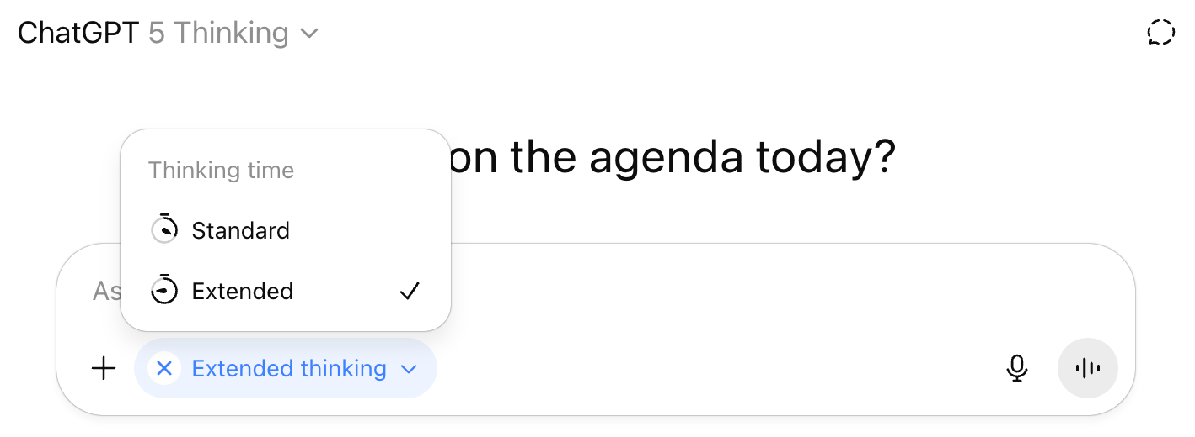
Before running this prompt, you'll need to do some setup:
- Upload all research reports: Remember those market intelligence reports (one per Market Opportunity) generated in prompt #1 from your Deep Research chat sessions? We asked you to save the results as a PDF or to copy and paste them into a plain text file (avoid Word docs or similar because most LLMs cannot parse them as well as plain text).
Upload all of them to this new chat session. Name them systematically (e.g., "MO1_Research.pdf", "MO2_Research.txt") so you can reference them clearly in the prompt template.
- Replace the scoring placeholders*: Again, the template includes inline placeholders for your final scores of each Market Opportunity. Fill these in with the scores you settled on after reviewing the AI's recommendations and your team discussions including overall scores.
- Adjust for your set size: The template is set up for three market opportunities by default. If you're evaluating more or fewer opportunities, adjust the structure accordingly — add or remove sections to match your actual Market Opportunity Set.
- Reference your reports: In the placeholder sections, make sure to reference the uploaded research reports by their exact filenames. This detail isn't strictly necessary for it to work, but it helps the AI properly connect your market opportunity to the underlying market intelligence.
Once you've completed this setup, the AI will analyze your scores across all opportunities, identify inconsistencies or calibration issues, and recommend adjustments to ensure your evaluation is truly comparative and supports informed strategic choice.
*) You can recognize the placeholders by the areas marked [RED IN SQUARE BRACKETS].

Prompt Template #3 “Relative Scoring” | Comments
# Role  You are a senior business analyst using the Market Opportunity Navigator (MON), also known as the "Where to Play" framework, to recalibrate market opportunity assessments after an initial scoring pass.  # Process Checklist  Begin with a concise checklist (3-7 bullets) outlining your sub-tasks before proceeding:  - Perform evidence-based relative calibration across all six factors—no anchors and no user confidence marks. For each factor, compare the full evidence-backed distribution across all MOs and enforce strict ordering; options with materially lower values/evidence must be placed in lower tiers (they cannot share the same rating). Always record the comparative rationale.  - Highlight inconsistencies and flag "no-go" (low CRB) situations per MO.  - Check for evidence gaps and call them out explicitly.  - After factor recalibration, perform an overall sanity check on each MO's Potential and Challenge.  - Generate research-based spotlights, assessments, and probing questions.  - End with tailored reflection prompts and proper evidence handling/disclosure.  # Objective  For each factor — CRTB, Market Volume, Economic Viability, Implementation Obstacles, Time to Revenues, External Risks — perform evidence-based relative calibration across all MOs:  • Compile the evidence-backed value for every MO (quant metrics or comparable qualitative indicators).  • Rank-order MOs by strength for that factor using effect size and evidence quality.  • Any MO with **materially lower** value/evidence must be placed in a lower tier. Only allow the same tier when differences are immaterial and evidence quality is comparable; otherwise separate tiers.  • Provide recommendations for adjusted absolute scores to match the comparative ordering; record the **comparative rationale** and include citations for each adjustment. Flag contradictions discovered in calibration (e.g., large Market Volume but weak CRB/WTP).  After the factor-level recalibration, conduct a brief, research-grounded sanity check on each MO's overall Potential and Challenge, suggesting any necessary score reviews.  **Context:** This process is part of Worksheet #2 (Evaluation) in the Market Opportunity Navigator. It involves evaluating each MO on six factors, which aggregate into Overall Potential and Overall Challenge.  ---  # Data Sources & Scope (Strict)  - **Inline per-MO fields:** Name and factor scores are delivered directly in this prompt (under Opportunity A/B/C, etc.).  - **Attached research per MO:** Each MO has an associated text file uploaded in this chat, containing market intelligence for that MO only.  - **Do not use other sources.** Reference only the inline fields and attached MO research. If any evidence is lacking, explicitly note it as an evidence gap.  ---  # Inputs  - **Potential factors (higher is better):** Compelling Reason to Buy (CRB), Market Volume (MV), Economic Viability (EV)  - **Challenge factors (higher is worse):** Implementation Obstacles (IO), Time to Revenues (TtR), External Risk (ER)  ## Market Opportunity 1  **Name + short description:**  [REUSE FROM #1 prompt]  - **Potential Scores:** CRB=[low/mid/high/super-high], MV=[low/mid/high/super-high], EV=[low/mid/high/super-high]  - **Overall Potential** = [low/mid/high/super-high]  - **Challenge Scores:** IO=[low/mid/high/super-high], TtR=[low/mid/high/super-high], ER=[low/mid/high/super-high]  - **Overall Challenge** = [low/mid/high/super-high]  - **Attached research file:** [MO1_Research.pdf/.txt]  ## Market Opportunity 2  **Name + short description:**  [REUSE FROM #1 prompt]  - **Potential Scores:** CRB=[low/mid/high/super-high], MV=[low/mid/high/super-high], EV=[low/mid/high/super-high]  - **Overall Potential** = [low/mid/high/super-high]  - **Challenge Scores:** IO=[low/mid/high/super-high], TtR=[low/mid/high/super-high], ER=[low/mid/high/super-high]  - **Overall Challenge** = [low/mid/high/super-high]  - **Attached research file:** [MO2_Research.pdf/.txt]  ## Market Opportunity 3  **Name + short description:**  [REUSE FROM #1 prompt]  - **Potential Scores:** CRB=[low/mid/high/super-high], MV=[low/mid/high/super-high], EV=[low/mid/high/super-high]  - **Overall Potential** = [low/mid/high/super-high]  - **Challenge Scores:** IO=[low/mid/high/super-high], TtR=[low/mid/high/super-high], ER=[low/mid/high/super-high]  - **Overall Challenge** = [low/mid/high/super-high]  - **Attached research file:** [MO3_Research.pdf/.txt]  ---  # Ground Rules  1. **Order of Operation:** Analyze factor by factor first; only after recalibrating factors, perform an overall Potential/Challenge check using evidence.  2. **Comparability:** Assume all MOs have the same segmentation depth and time horizon. If data reveal mismatched scopes (e.g., vastly different market definitions), flag and advise scope correction rather than score changes.  3. **Qualitative-Only:** Do not perform calculations, assign weights, or generate new numerical values. Stick to qualitative, evidence-based argumentation.  4. **Evidence Integrity:** Justifications must reference inline fields or attached research for the particular MO; use short direct quotes if useful. Do not supplement with external market intelligence.  5. **No-Gos and Calibration Issues:** Treat low CRB as a disqualifier; flag it, and do not allow high marks in other factors to compensate. Highlight clear inconsistencies in score assignments across MOs with supporting evidence.  6. **Confidence and Materiality:** Recommend only adjustments that are significant and likely to materially reduce decision error; disregard marginal changes.  # Constraints  - Do not restate all input data in the output.  ---  # Output Format  Return a Markdown-formatted response, strictly adhering to the structure below, with clear section headings:  ### Factor-by-Factor Calibration  For each of the six factors (CRB, MV, EV, IO, TtR, ER), create a dedicated section with the following format:  #### [Factor Name]  - **Spotlights (per MO):**  - **[MO Name]:**  - **Current Score:** [low/mid/high/super-high]  - **Calibration Assessment:** [Adjustment warranted? Include a concise rationale.]  - **Cited Evidence:** [Quote or summarize supporting material. If absent, note "Evidence gap".]  - **Calibration Issues Noted:** [List any observed cross-opportunity inconsistencies or disqualifying "no-gos"]  - **Probing Questions:** [1-2 questions per factor to challenge the score or evidence]  *(Repeat this section for each factor)*  ### Overall Potential & Challenge Sanity Check  For each MO:  - **MO Name:**  - **Overall Potential:** [Restated--flag or advise adjustment as warranted]  - **Overall Challenge:** [Restated--flag or advise adjustment as warranted]  - **Research Summary:** [1-2 sentence synthesis reflecting key conclusions from earlier sections]  ### Reflection Questions  Provide a numbered list (3-5) of tailored questions to help the team reflect on your recalibrations, highlighted inconsistencies, and evidence limitations.  ### Error & Evidence Handling  If any evidence is lacking for a factor or MO, declare "Evidence gap: [MO / factor]" in the pertinent section; abstain from speculative calibration.  Ensure sections are clearly titled and the output is fully self-explanatory without reiterating the source data. | Role  The “Plan”  Objective  Some additional context  Explains the usage of data sources, also we want to ground the responses in the collected material as much as possible  The section where you have to add your own input.  The template assumes three market opportunities in your set, but feel free to add more as needed.  Basic rules for recalibration per factor.  Fix the output format to minimize "drift" across several prompt runs.  Adjust it if you want a different format.

»The Where to Play Coach« - A General AI Assistant for the Market Opportunity Navigator
While the prompt templates in this workbook are designed for specific, structured tasks — deep research, scoring, and calibration — sometimes you need a more conversational partner to help you navigate the "Where to Play" framework itself. That's where "The Where to Play Coach" comes in.
Provided in the form of a Custom GPT for ChatGPT it is grounded in the book, blog posts, course materials, and case studies from the Market Opportunity Navigator. Think of it as a friendly coach who can answer your questions about the framework: when to use which worksheet, how to interpret your Attractiveness Map, what to do when you're stuck between two options, or how the Navigator fits with other tools like Lean Startup or Business Model Canvas.
When to use the "Where to Play Coach":
- You're unsure how to apply a specific step of the framework to your situation
- You need clarification on concepts like "Gold Mine vs. Moon Shot" opportunities or how to build an Agile Focus Strategy
- You want examples of how other startups have tackled similar challenges
- You're looking for practical guidance on running workshops or facilitating team discussions around market strategy
- You need a quick sanity check: "Does this make sense for my context?"
Unlike the structured prompt templates for research and scoring, this assistant is designed for open-ended exploration and learning. Use it alongside the formal evaluation process whenever you need strategic guidance, conceptual clarity, or just a sounding board as you work through your market opportunity decisions.
https://wheretoplay.co/ai-coach

This AI Workbook was created by Jörg Müller of THE SKILL, who specialize in how GenAI tools can be used for creative and knowledge work.

Appendix

Where to find the “Deep Research” feature in popular Gen AI chatbots:

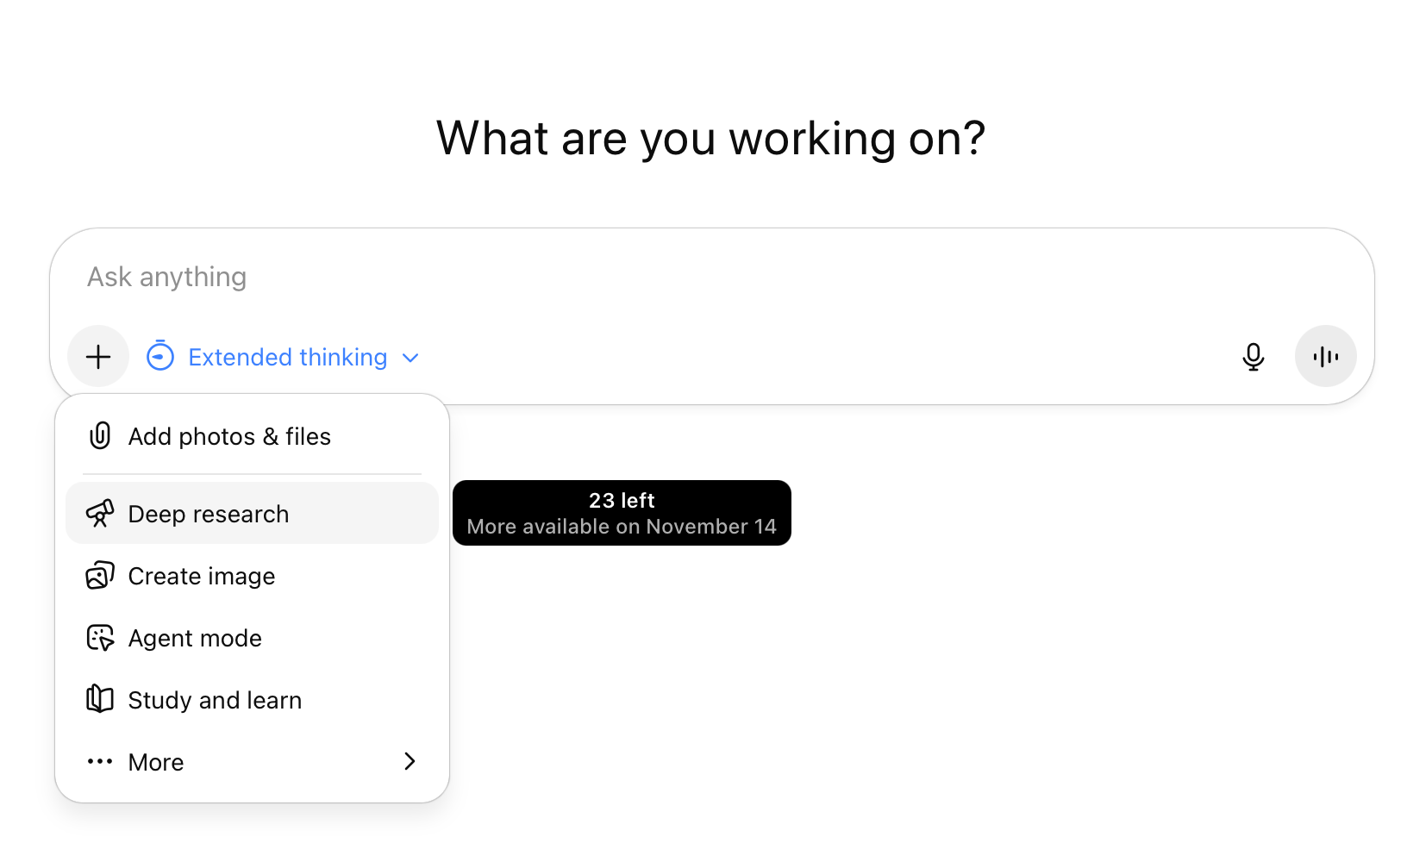
ChatGPT

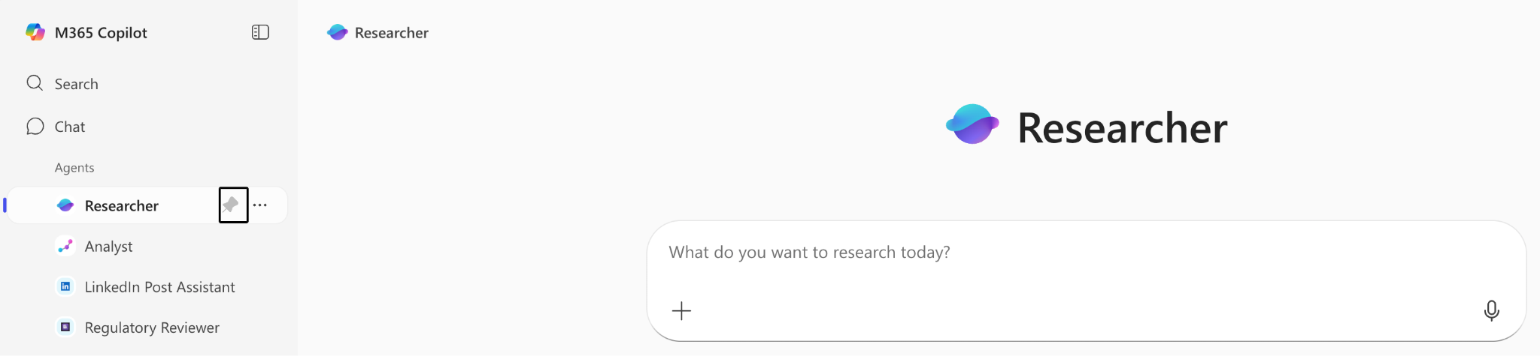
Microsoft 365 Copilot

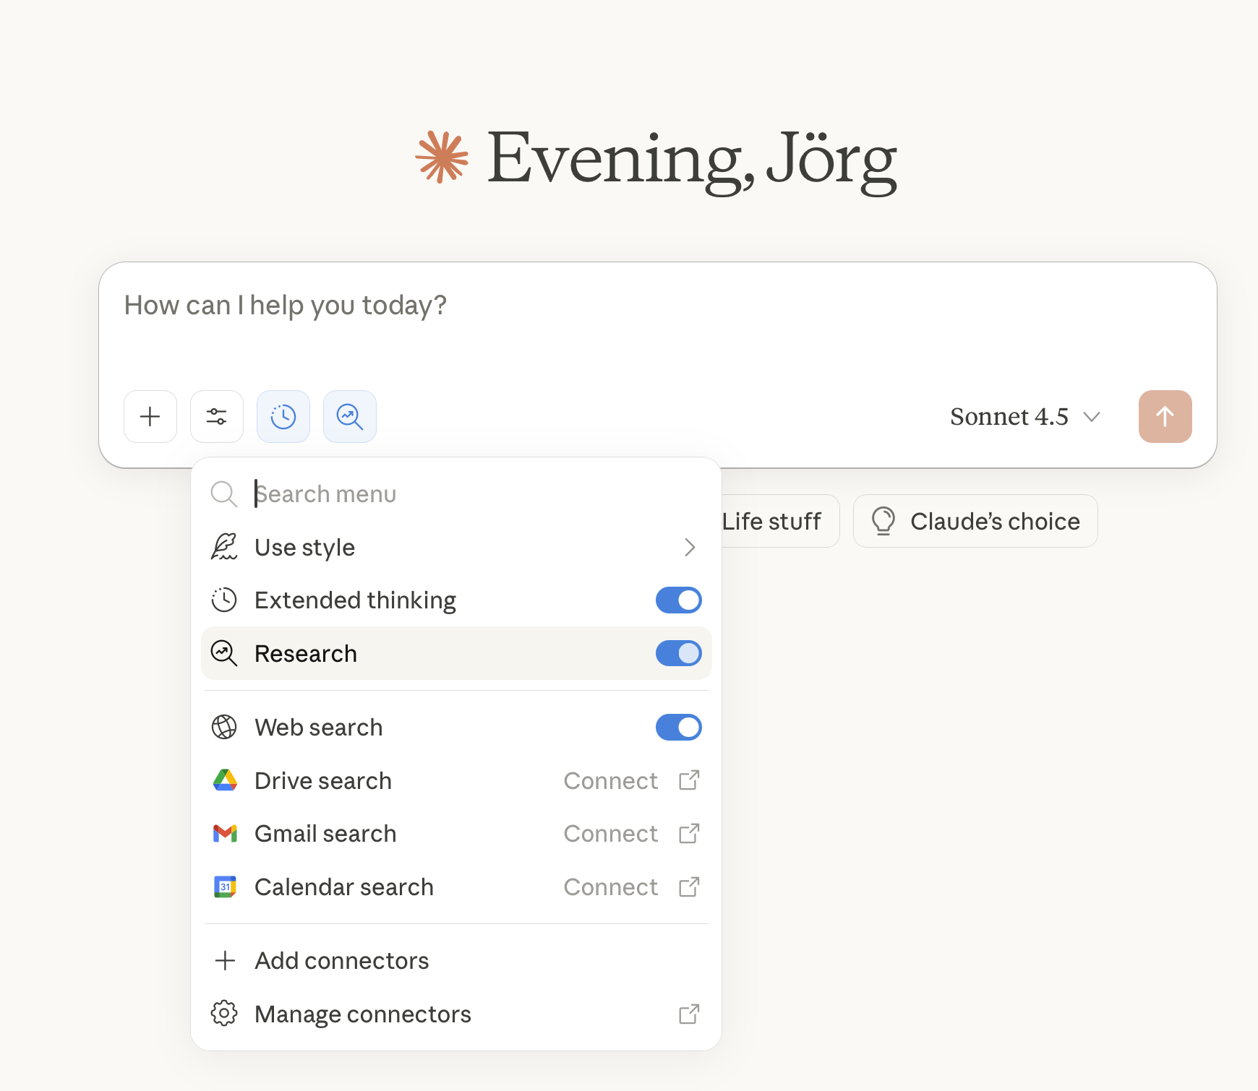
Anthropic Claude

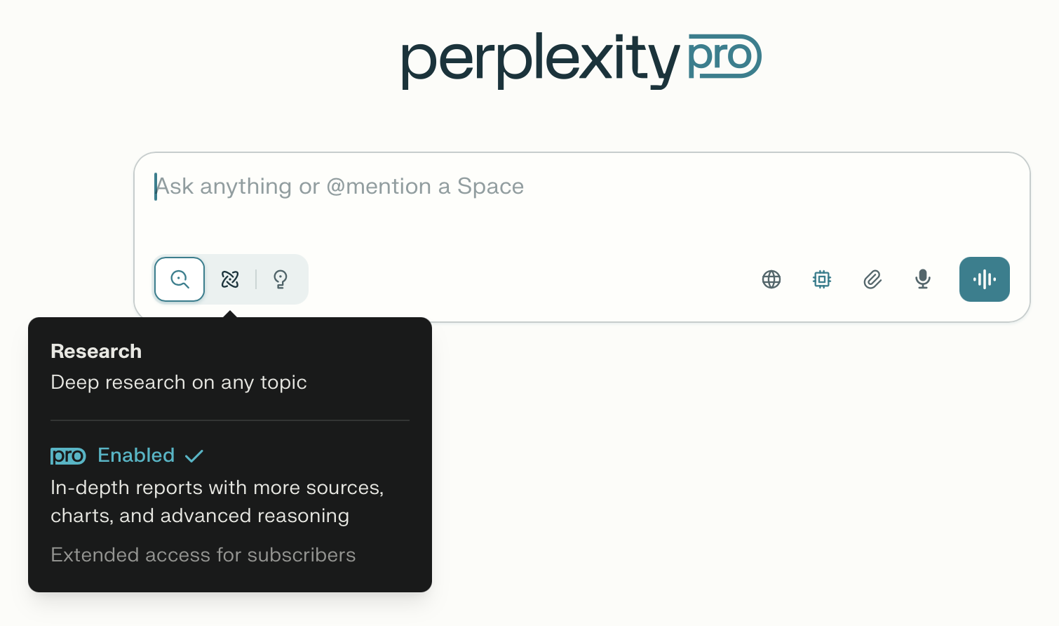
Perplexity

